The Fringe – Investor’s Prospectus (Brief)
Rick Pingry, June 28, 2008
We are currently in the early development stages of The Fringe, a Sci-Fi Space Simulation Massively Multi-Player Online Game (MMOG). This investor’s prospectus briefly describes the investment opportunities available in this venture. Thank you so much for taking a look. Please contact me at rick@fringe-online.com if you have any questions or would like to check out an exclusive VIP demo of the game. You can also see the latest in the on-going development effort at http://fringe-online.com. Throughout this document, you will see references to industry research. All of this data can be found at http://www.mmogchart.com.

Predicted Revenues and Returns
Like most MMOGs, The Fringe will use subscriptions for revenues. Rather than paying once for the game off the shelf, the players will download the game for free, and then pay each month to be a part of The Fringe universe. We are basing our subscription estimates on another Sci-Fi MMOG game, Eve-Online. Here is an excerpt from the afore-mentioned definitive industry research about EVE:

Eve Online has quietly been a real success story since their launch on May 6, 2003, starting out small and slowly building more and more subscribers, with almost no competition in the market for its particular brand of sci-fi space simulation. As of February 2008, EVE Online has 224,942 subscribers. {Note that these subscribers are paying $16 per month} see http://www.mmogchart.com

We plan on being a part of that much-needed competition. We are basing our early subscription numbers on EVE’s historical data, which exceeded 100,000 by April of 2006, three years after launch. Our game includes space combat excitement and other features that are not to be found in EVE, or anywhere else on the internet.

Building a fully fledged Massively Multi-Player Online Role Playing Game (MMORPG) is a monumental task that takes years of development and millions of dollars. We plan on accomplishing this task by bringing a smaller game to market, and then building on that game over time as EVE did. We will be charging a subscription of $7 - $12 per month for our entry-level game, then providing paid and non-paid upgrades as we go.

The following table shows an estimate of the subscriptions for The Fringe for the first 36 months after launch (which should start 1 year after we begin production). It is based on a conservative estimate of 50% of the Eve Online active subscriptions chart shown above, at a rate of $7 per month. No other income streams are considered here.

Another important point to consider is that these return rates are conservative in that in the three years after launch, we will also be working on the full version of the Fringe, which will start with a $12 - $16 monthly subscription. We expect that large numbers of “Fringe-Miramar Station” players will move up to this full-fledged MMORPG.

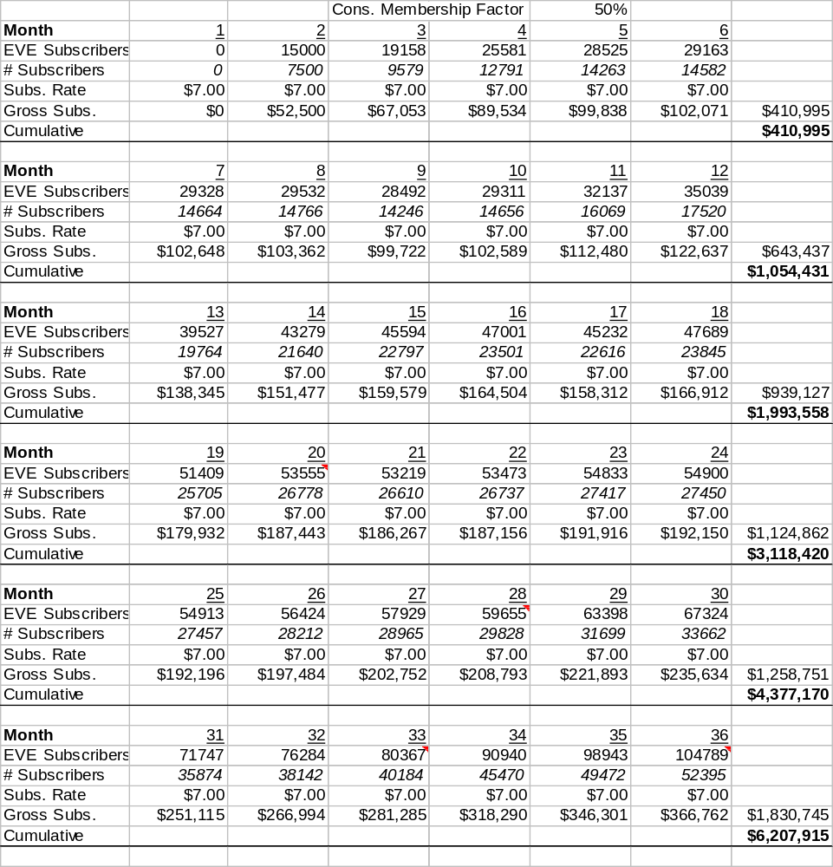
Projected Subscription Revenue

Additional Revenue Streams
We are excited about the other revenue streams that can be brought to play with The Fringe. While subscriptions are our primary source of revenue, we will also be able to merchandise tee-shirts, hoodies, mouse pads, hats, and any other print materials, like folders for school. In the long term, we plan on selling toys that mimic the ships that the players fly, with the innovative feature that allows players to print out stickers that mimic the color schemes of their ship in the game and apply them to their toy.

The beauty behind merchandising is not just that it is an additional revenue stream, but that it is a built in low-cost marketing technique. We have described this and other revenue streams and marketing techniques (including a web-cast show that highlights the storyline of the game) in our detailed investor’s prospectus.

Development Costs
We estimate a development cost of $500k. This estimate is based on our development experience with the game to date, as well as the cumulative development experience of our team. It also takes into account a contingency plan that will allow us to add features and other technical improvements in response to changes in the gaming industry. The table at the end of this document details how those funds will be allocated.

Capital Procurement Plan
While we fully expect The Fringe to be a smashing success and take over the gaming world, we realize that we need to take measured steps in our capital procurement plan and not immediately seek for millions of dollars from venture capitalists, or have a public stock offering. We want to grow in measured steps, and take our investors, our angels, along with us for the ride. Generally, our investment strategy follows these steps:

- Use personal funds to get the first proof of concept game demonstrations working.
- Invite friends and relatives to invest short term as an unsecured loan to help us get the business organization structured and get the technical demo working and in the hands of full development investment opportunities.
- Procure the $500k in starting capital we need to get through the first year of full production and a public paid launch of the game.
- After we have a public launch and the game is out there, we may use our track record and real revenue results and look for venture capitalists that can help us manage growth and take the game and the business to the next level.
- As we grow the mature game to world-class proportions, we may provide a public stock offering that will lift us and all of our investors to the MOON!

We are currently in step 2 of this plan. We already have a proof of concept demonstration, and we have been able to get some investment capital from friends and family. The details of step two and three are described below. As a potential investor, we hope that you will look seriously at one of these options and become part of our team.

Short Term Investment
We have made some great strides working on the game in our spare time, but we can see that the market is passing us by. If you have a few thousand dollars to invest, we are looking for some initial capital so that we can focus on development of this demo and the first release of the game. We estimate the time it will take for us to gain investors and/or release the first version of the game, and start seeing revenue from that, should be less than one year. If we are able to obtain funding from a primary source, the time should be much less than that. We expect that fifteen to twenty thousand dollars will help us reach that goal.

We do not need to procure the full amount from a single investor. Indeed, we already have several investors that have committed to more than $6,000. Our plan is to consider this investment as an unsecured loan with repayment contingent on either finding venture capital or releasing the game. If we procure venture capital, we will begin to repay the debt in full at a minimum rate of 5% of the initial investment per month. If not, upon first public-paid release of the game, we will begin repayment 3 months after game release at a minimum rate of 5% of the initial investment per month. We realize that there is a certain amount of risk involved with this, and we want to make sure you are well compensated for it. While payments on this loan are deferred, the interest will begin to accrue from the first month we receive the money at a rate of 2% compounded monthly (26.82% APR), and interest will continue to accrue until the loan is repaid in full. You may also choose to take some or all of the payment as stock options along with our “Full Development Investors” shown below.

Please contact me if you would like to have a part in this opportunity. A promissory note is included in this packet that would serve as the legal agreement.

Full Development Investment
As we mentioned earlier, we expect the full development cost of this venture to take one year and cost $500k. We are looking for investment for this amount, and we plan on providing stock options for that investment, but we are flexible. Please contact me so we can work out the details.

Thank You!
Thank you so much for taking the time to look at this opportunity. If you would like to know more, check out the detailed investment prospectus that provides more insights into our business plan. You can also check out the exciting art and content we have already completed. You might also ask for an exclusive VIP demo showing the game so far. We also have a document that describes the story line that goes along with the Fringe Universe, and details the plan we have for releasing various expansions to the game.

If either of the immediate investment options is intriguing to you, please contact me anytime.

Rick Pingry
(540) 598-6262
rick@fringe-online.com

1 Year Production Expense Plan
